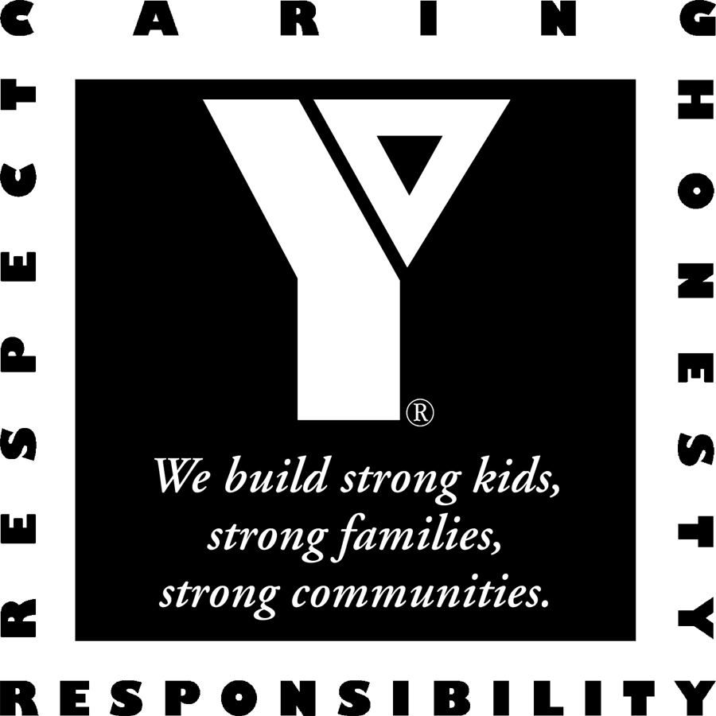
YMCA of the Inland Northwest
Rental Confirmation

Hello!
Welcome and thank you for choosing the YMCA as the place to gather and celebrate your special event with friends and/or family.

Group Name: Washington State University – Nutrition Education
Mailing Address: 222 N Havana, Spokane, WA 99202
Contact Name: Summer Goetz
Contact Phone: 509-477-2656
E-mail: sgoetz@wsu.edu

Our records show you have elected to reserve the following for the following date:

Central Spokane YMCA – Sunday, December 13, 2009

Arrival Time: 12:00 pm Departure Time: 4:00 pm

Meeting Room 1: 12:00 - 4:00 pm

Non-Exclusive Use of Areas
Gymnasium: Open to members and guests
Pool: 12:30 – 3:30 pm Slide/Toys/Wading Pool: OPEN
Teen Center: 2:00 – 9:45 pm Ages 12-18 years old
Family Activity Center: Open to members and guests
must have adequate supervision of children in group

Number of Attendees: 30 participants + staff
must contact us 1 week prior if numbers change or additional fees may apply

Discounted Day Pass Rates for Group / Price per Participant: $ 5.00

Additional Information/Fees: Adult Leaders may be asked for Photo ID – please have available

Please review your confirmation and enclosed information. You must contact us as soon as possible if you notice any indiscretions or require any changes. Group leaders must familiarize themselves with the YMCA’s policy and procedures and are responsible for communicating these to participants.

Central YMCA 930 N Monroe, Spokane, WA 99201
Phone: (509) 777-YMCA (9622) Fax: (509) 927-1466

