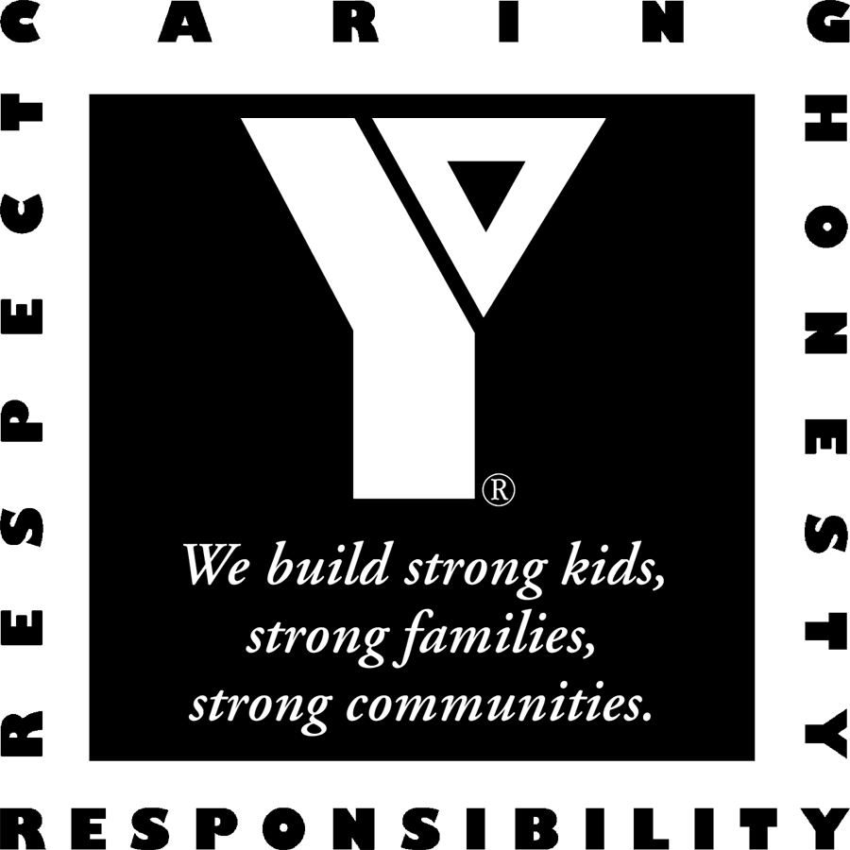
YMCA of the Inland Northwest
Rental Confirmation

Hello!
Welcome and thank you for choosing the YMCA as the place to gather and celebrate your special event with friends and/or family.

Group Name: West Central Community Center (ID#176012)
Mailing Address: 1603 N Belt, Spokane, WA 99205
Contact Name: Rich Harris
Contact Phone: 509-323-7501
E-mail:

Our records show you have elected to reserve the following for the following date:

Central Spokane YMCA – Wednesday, December 23, 2009

Arrival Time: 1:00 pm Departure Time: 4:00 pm

Non-Exclusive Use of Areas
Gymnasium: Open to members and guests
Pool: 1:00 pm – 3:30 pm Slide/Toys/Wading Pool: OPEN
Family Activity Center: Open to members and guests
must have adequate supervision of children in group

Number of Attendees: 30 youth + adults
must contact us 1 week prior if numbers change or additional fees may apply

Discounted Day Pass Rates for Group / Price per Participant: $ 4.00

Additional Information/Fees: Adult Leaders may be asked for Photo ID – please have available

Please review your confirmation and enclosed information. You must contact us as soon as possible if you notice any indiscretions or require any changes. Group leaders must familiarize themselves with the YMCA’s policy and procedures and are responsible for communicating these to participants.

Central YMCA 930 N Monroe, Spokane, WA 99201
Phone: (509) 777-YMCA (9622) Fax: (509) 927-1466

